Paper Submission Guide for the 20th IACP International Conference on China Planning

Step 1: Log in: [https://cmt3.research.microsoft.com/IACP2026] If you do not have a CMT account, please register one before submitting. Co-authors do not need to register, but you still need to enter the information of all co-authors when submitting the abstract.

Step 2: Click the "Create New Submission" button, then select "Research Paper Track" or "Innovative Practice Track" based on your submission track:
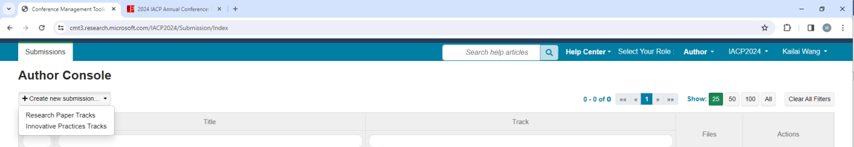

Step 3: Example for a "Research Paper Track" submission: Please enter the required information (if there are co-authors, enter their email to start inputting their information), select the relevant subject areas, and then click the "Submit" button to complete the process.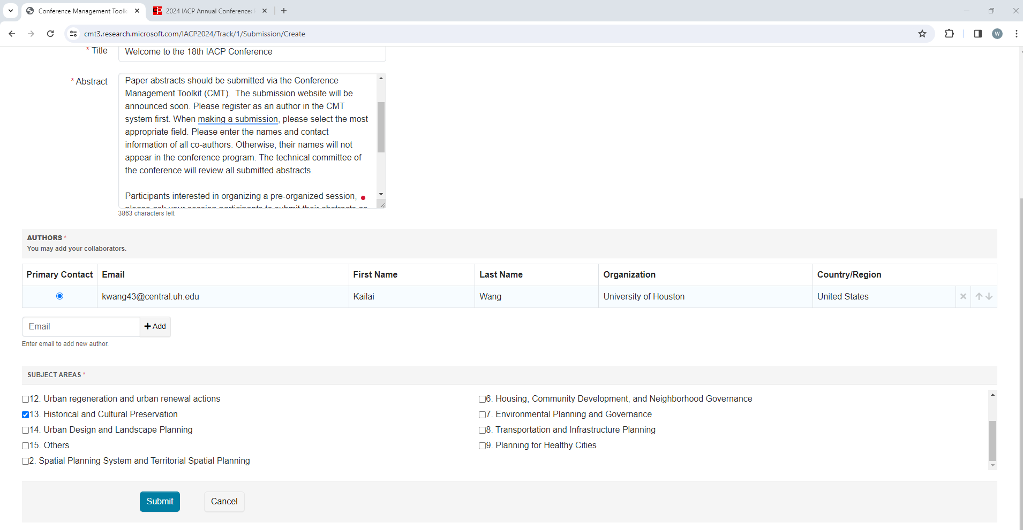

Step 4: Review and update conflicts of interest. Select "Complete" to confirm and save changes. If you have no conflicts of interest, click "Complete" to finish the submission.
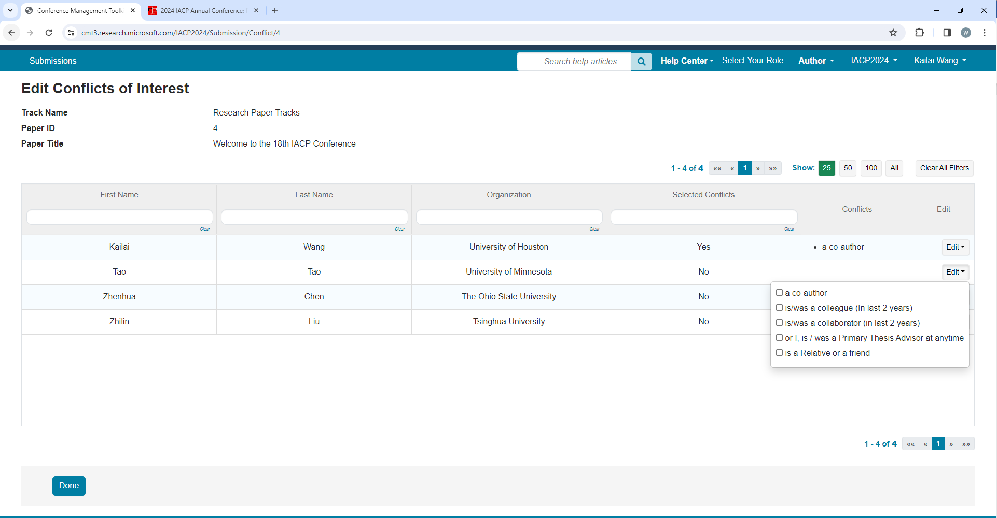
Step 5: If necessary, you can modify your submission at any time before the submission deadline.

